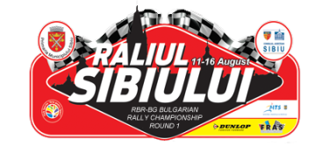
RBR-BG RALLY CHAMPIONSHIP
ROUND 1
RALIUL SIBIULUI
ITINERARY
 | Leg 1 | 11-13 August 2016
SS | Stage Name | RBR Stage | Time | Distance
SS 1 | Curmătură | Joux Plane |  | 11.1 km
SS 2 | Păltiniș | Joux Plane II |  | 11.1 km
 | Service A |  | 0:60
 | Total Leg 1 |  | 0:60 | 22.2 km

 | Leg 2 | 14-16 August 2016
SS | Stage Name | RBR Stage | Time | Distance
SS 3 | Călugăru | Cote D’Abroz |  | 4.5 km
SS 4 | Dobârca | Bisanne |  | 5.6 km
SS 5 | Călugăru | Cote D’Abroz |  | 4.5 km
 | Service B |  | 0:30
SS 6 | Dobârca | Bisanne |  | 5.6 km
SS 7 | Șugag | Foron |  | 9.2 km
SS 8 | Oașa | Sorica |  | 15.5 km
 | Service C |  | 0:15
SS 9 | Oașa | Sorica |  | 15.5 km
SS 10 | Șugag | Foron |  | 9.2 km
SS 11 | Poiana Sibiului | Livadija II |  | 5.5 km
 | Service D |  | 0:15
SS 12 | Super Special | Karowa 2009 |  | 1.6 km
 | Total Leg 2 |  | 0:60 | 76.7 km

Leg 1 Thursday – Saturday – 2 SS | 22.2 km
Leg 2 Sunday – Tuesday – 10 SS | 76.7 km
Total Rally – 12 SS | 98.9 km

